
Name: T NITHIN KUMAR
Reg. No: 192424351
Course Code: DSA 0502
Course Name: Query Processing for Data Science
Slot: Slot D
Faulty Name: Dr. B .SHYAMALA GOWRI

TIME-BASED DATA ANALYSIS
MONTHLY SALES TREND
Python Data Analysis using Pandas & Matplotlib

Lab Record / Assignment Documentation

1. AIM
To convert the Date column of a monthly sales dataset into DateTime format using Pandas, and to analyze and visualize the sales trend over time using a line graph.
2. PROCEDURE
Step 1: Import the required libraries — pandas for data handling and matplotlib.pyplot for plotting.
Step 2: Create a sample monthly sales dataset with two columns, Date and Sales, and load it into a Pandas DataFrame.
Step 3: Convert the Date column from text to DateTime format using pd.to_datetime().
Step 4: Set the Date column as the DataFrame index to make time-based analysis easier.
Step 5: Extract Month and Year from the DateTime index for reference.
Step 6: Perform basic trend analysis — total sales, average sales, highest and lowest sales month, and month-over-month growth percentage.
Step 7: Plot the Sales column against the Date index using a line graph with matplotlib to visualize the trend.
Step 8: Display the DataFrame, analysis results, and the graph as the final output.
3. PYTHON PROGRAM
The following program creates a sample dataset, converts the Date column to DateTime, analyzes the sales trend, and plots a line graph.
import pandas as pd
import matplotlib.pyplot as plt

# ==================== CREATE SAMPLE MONTHLY SALES DATASET ====================
data = {
"Date": ["2024-01-01", "2024-02-01", "2024-03-01", "2024-04-01",
"2024-05-01", "2024-06-01", "2024-07-01", "2024-08-01",
"2024-09-01", "2024-10-01", "2024-11-01", "2024-12-01"],
"Sales": [15000, 18000, 17500, 21000, 23000, 22500,
25000, 27000, 26500, 29000, 31000, 34000]
}

df = pd.DataFrame(data)

# ==================== CONVERT DATE COLUMN TO DATETIME ====================
df["Date"] = pd.to_datetime(df["Date"])

# Set Date as index for easier time-based analysis
df.set_index("Date", inplace=True)

print("=" * 55)
print("SALES DATASET (with Date converted to DateTime)")
print("=" * 55)
print(df)
print("\nData type of index:", type(df.index))

# ==================== EXTRACT MONTH AND YEAR ====================
df["Month"] = df.index.month
df["Year"] = df.index.year

print("\n" + "=" * 55)
print("DATASET WITH MONTH AND YEAR EXTRACTED")
print("=" * 55)
print(df)

# ==================== BASIC SALES TREND ANALYSIS ====================
total_sales = df["Sales"].sum()
average_sales = df["Sales"].mean()
max_sales = df["Sales"].max()
min_sales = df["Sales"].min()
max_month = df["Sales"].idxmax().strftime("%B %Y")
min_month = df["Sales"].idxmin().strftime("%B %Y")

print("\n" + "=" * 55)
print("SALES TREND ANALYSIS SUMMARY")
print("=" * 55)
print(f"Total Sales for the Year : {total_sales}")
print(f"Average Monthly Sales : {average_sales:.2f}")
print(f"Highest Sales : {max_sales} in {max_month}")
print(f"Lowest Sales : {min_sales} in {min_month}")

# Month-over-month growth (%)
df["Growth %"] = df["Sales"].pct_change() * 100
print("\n" + "=" * 55)
print("MONTH-OVER-MONTH GROWTH (%)")
print("=" * 55)
print(df[["Sales", "Growth %"]].round(2))

# ==================== PLOT SALES TREND (LINE GRAPH) ====================
plt.figure(figsize=(10, 5))
plt.plot(df.index, df["Sales"], marker="o", color="blue", linewidth=2)
plt.title("Monthly Sales Trend - 2024")
plt.xlabel("Month")
plt.ylabel("Sales (Rs.)")
plt.grid(True)
plt.xticks(rotation=45)
plt.tight_layout()
plt.savefig("sales_trend.png")
plt.show()

print("\nLine graph 'sales_trend.png' generated successfully.")

4. SAMPLE OUTPUT
Sales Dataset (Date converted to DateTime, set as index)
Date | Sales
2024-01-01 | 15000
2024-02-01 | 18000
2024-03-01 | 17500
2024-04-01 | 21000
2024-05-01 | 23000
2024-06-01 | 22500
2024-07-01 | 25000
2024-08-01 | 27000
2024-09-01 | 26500
2024-10-01 | 29000
2024-11-01 | 31000
2024-12-01 | 34000
Data type of index: pandas.DatetimeIndex
Sales Trend Analysis Summary
Metric | Value
Total Sales for the Year | 289500
Average Monthly Sales | 24125.00
Highest Sales | 34000 in December 2024
Lowest Sales | 15000 in January 2024
Month-over-Month Growth (%)
Date | Sales | Growth %
2024-01-01 | 15000 | NaN
2024-02-01 | 18000 | 20.00
2024-03-01 | 17500 | -2.78
2024-04-01 | 21000 | 20.00
2024-05-01 | 23000 | 9.52
2024-06-01 | 22500 | -2.17
2024-07-01 | 25000 | 11.11
2024-08-01 | 27000 | 8.00
2024-09-01 | 26500 | -1.85
2024-10-01 | 29000 | 9.43
2024-11-01 | 31000 | 6.90
2024-12-01 | 34000 | 9.68
Line Graph — Monthly Sales Trend
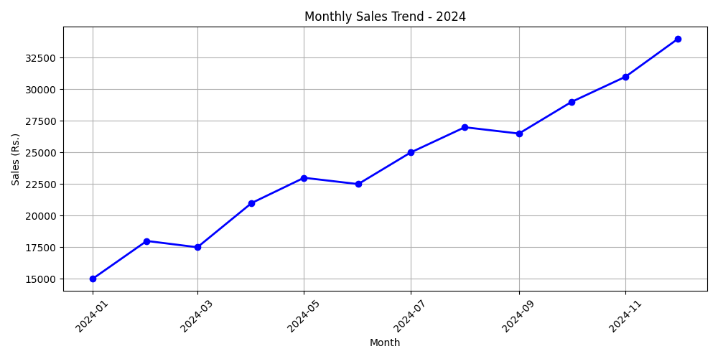
5. RESULT
The Date column of the monthly sales dataset was successfully converted into DateTime format using pd.to_datetime(), and was used as the DataFrame index for time-based analysis. The sales trend analysis showed a total yearly sales of Rs. 289500 with an average monthly sales of Rs. 24125. The line graph clearly shows an overall increasing sales trend from January to December 2024, with the highest sales in December and the lowest in January. Thus, the program to convert, analyze, and visualize time-based sales data was executed successfully.

